YOLO Object Detection System Report

1. Introduction
The model was trained to detect three distinct object classes:
- Red Cup
- Blue Bottle
- Phone
The project covers the complete machine learning pipeline from data collection and annotation, through model training and evaluation, to real-time deployment on a live webcam feed.

2. Dataset Collection
Our group divided the data collection task by assigning each member to gather images of one object type. This was done in order to avoid the duplication of images collected. The images was then unified in a shared Roboflow project for labeling and export the dataset.

3. Image Annotation
Each member annotated their assigned image class. Our group divided the data collection task by assigning each member to gather images of one object type. The images was then unified in a shared Roboflow project for labeling and export the dataset.
- Bounding boxes were drawn around the object class in the image and labelled the object.
- After labelling all the images dataset was then exported.
- The export format : YOLOv8
- Augmentation applied was flip horizontal
- Train / Val / Test split: 87% / 11% / 2%
- data.yaml file auto-generated with correct class names and paths

4. Model Training
Environment Setup
- Platform: Google Colab (T4 GPU runtime)
- Framework: Ultralytics YOLOv8
- Installation: pip install ultralytics
- Pretrained weights: yolov8n.pt (nano model, optimised for speed) But it was found to be less accurate when used in real time.
- Hence switched to yolo26n.pt for 50 epochs

5. Observations
The model was able to predict multiple objects in the image
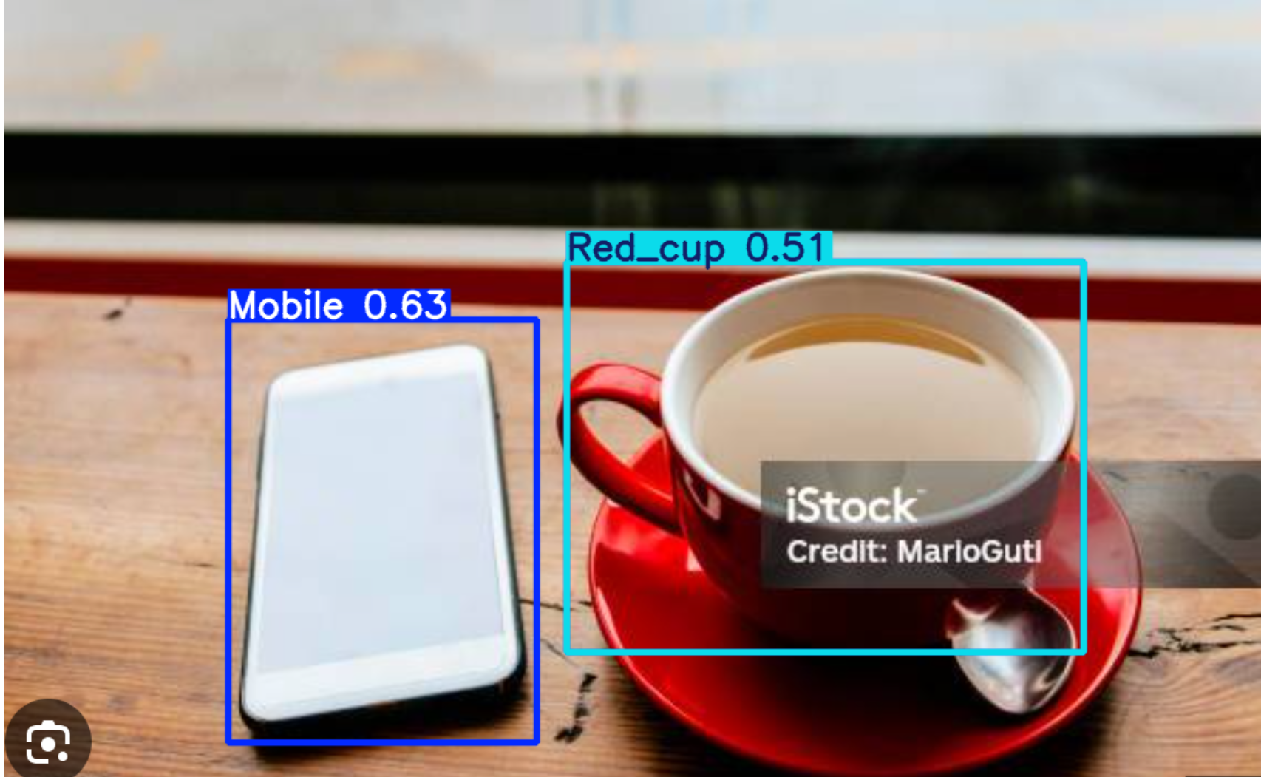

Even if the object was partially hidden (occlusion) it was able to predict correctly

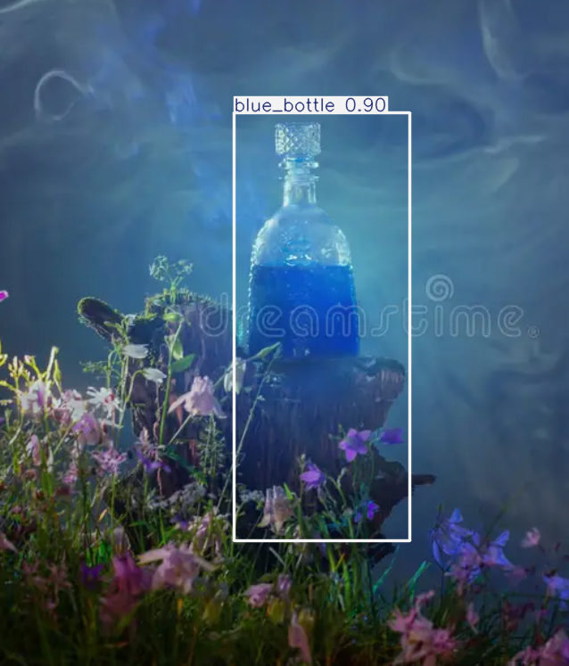

6. Webcam detection
Laptop was too slow that the webcam freezes almost every time. But it was doing well for the other team members with the same model. Giving pretty well accurate predictions.

7. Reflection
- Dividing data collection by class made the process efficient and manageable
- Roboflow's shared project enabled team collaboration on labeling
- Using pretrained YOLOv8 weights significantly helped that the model learned meaningful features quickly
- Augmentation helps in avoiding generalisation
- The main challenge was during the training, low performance system can take up hours for training even for 10 epochs. Google colab was helpful, but its usage expires fast for free versions

8. Improvements
- Collect more images in challenging conditions (night, reflective surfaces, extreme angles) to improve robustness
- Increase the number of training epochs to allow further convergence.

